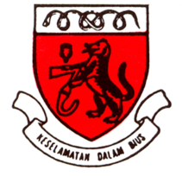

1ST TIVA/TCI WORKSHOP

ORGANIZING COMMITTEE

DR SALIMI MOHD SALLEH
DR SHARIFAH NOR MOHD SALLEH
DR LEE YAN WEI
DR YEOH CHIH NIE

ADVISOR

Datin Dr. Sivasakthi Velayuthapillai

IN COLLABORATION WITH

ABBOTT
MAYCARE

SPECIAL THANKS TO
GOT STAFF

RSVP

DR SALIMI MOHD SALLEH
Email : drtorhampala@yahoo.com
017-8822207
Limited to 20 participants
Closing date 13th June 2012

(Participants MUST have basic knowledge on tiva/tci prior to attending this workshop. The aim of this workshop is to highlight the practical aspects of tiva/tci. Please refer to TIVA pocketbook reference available on MSA website.)

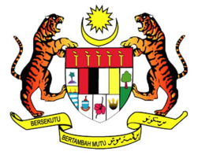
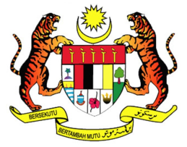

1ST TIVA/TCI WORKSHOP
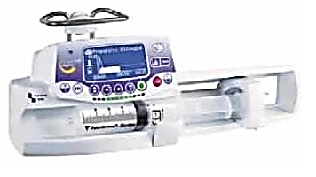

DATE

27TH JUNE 2012

COURSE FEE

RM 50/PERSON

VENUE

GENERAL OPERATION THEATRE (3RD FLOOR),
DEPARTMENT OF ANESTHESIA & INTENSIVE CARE, HKL

ORGANIZER

DEPARTMENT OF ANESTHESIA & INTENSIVE CARE, HKL
&
MALAYSIAN SOCIETY OF ANAESTHESIOLOGISTS

1ST TIVA/TCI WORKSHOP

PROGRAMME

0730 -0800 : REGISTRATION

0800- 0830 : BRIEFING & BREAKFAST

0900- 1200 : PRACTICAL TIVA/TCI : 2 OTs

1200-1215 : MCQ

1215- 1345 : LUNCH TALK
DR MUHAMMAD MAAYA,
CONSULTANT ANESTHETIST,
UKMMC

1345- 1545 : PRACTICAL TIVA/TCI : 2 OTs

1545- 1600 : FEEDBACK & QA

